CO5 — ASSESSMENT 1: CONSTRAINT-BASED PROBLEM SOLVING
Student Name: K. Manoj Kumar Reg. No.: 192472395
Section / Batch: 2024 Date: 23/08/2026

QUESTION 1 — REAL-TIME FACE RECOGNITION FOR CAMPUS SECURITY
Question: A university wants to deploy a camera-based security system at the entrance that can identify registered students and staff in real time. The system should capture faces from live CCTV/video streams, detect faces under different lighting conditions, extract suitable facial features, recognize registered individuals, maintain real-time performance on a low-cost computer, and minimize false recognition. Design a complete OpenCV-based face recognition pipeline from image acquisition to final identification.
We will design an end-to-end OpenCV face recognition pipeline that acquires live video, normalizes lighting, detects and aligns faces, extracts discriminative features, matches them against a registered database, and reports identity in real time on limited hardware.
1. Problem Analysis
Campus entrance recognition is a constrained real-time vision problem: the system must process a continuous video stream under uncontrolled lighting, keep latency low on inexpensive hardware, and avoid granting access to unregistered individuals. This requires a pipeline that separates fast coarse operations (detection) from slower precise operations (recognition), and that normalizes input before feature extraction so that lighting variation does not degrade accuracy.
2. Concepts / Techniques Applied
- Frame Acquisition — cv2.VideoCapture reads frames from the CCTV/RTSP stream.
- Preprocessing — grayscale conversion and CLAHE (Contrast Limited Adaptive Histogram Equalization) to normalize illumination differences.
- Face Detection — a fast Haar Cascade or a DNN-based detector (OpenCV's res10 SSD face detector) locates face bounding boxes.
- Face Alignment — eye-landmark based rotation/scaling so faces are presented consistently to the recognizer.
- Feature Extraction — LBPH (Local Binary Pattern Histogram) for a lightweight CPU-only solution, or a compact deep embedding network (e.g., OpenFace/dlib ResNet) for higher accuracy.
- Recognition / Matching — compares the extracted feature vector against a registered-face database using a distance metric (Euclidean/cosine) with a confidence threshold.
- Optimization — frame skipping, ROI-based tracking between detections, and multithreaded capture/inference queues to sustain real-time frame rate.
3. System Architecture
LIVE CCTV / VIDEO STREAM
|
v
+-----------------------+
| Frame Acquisition |
+-----------+-----------+
|
v
+-----------------------+
| Preprocessing (Gray, |
| CLAHE, Resize) |
+-----------+-----------+
|
v
+-----------------------+
| Face Detection (Haar/ |
| DNN SSD) |
+-----------+-----------+
|
v
+-----------------------+
| Face Alignment |
+-----------+-----------+
|
v
+-----------------------+ +----------------------+
| Feature Extraction |<----->| Registered Face DB |
| (LBPH / Embeddings) | | (Feature Vectors) |
+-----------+-----------+ +----------------------+
|
v
+-----------------------+
| Matching & Threshold |
| Decision |
+-----------+-----------+
|
v
Identified / Unknown -> Display + Access Log
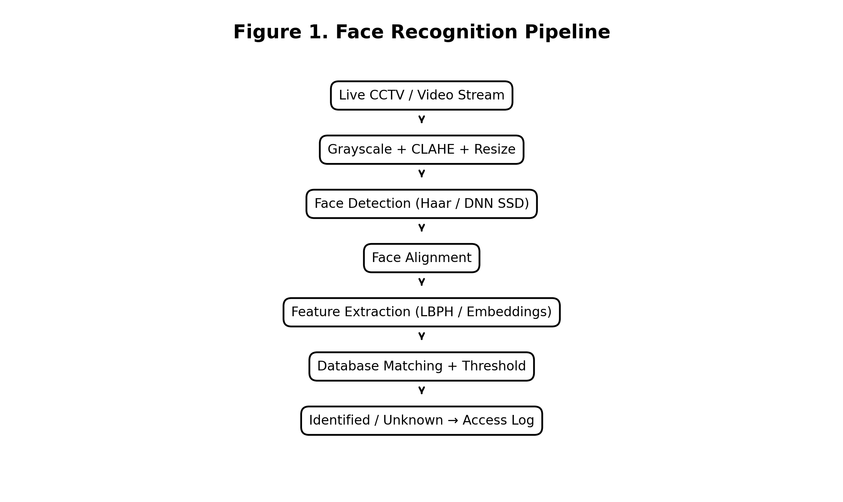
Figure 1. OpenCV-based real-time face recognition pipeline.
4. Step-by-Step Implementation
- Capture frames continuously with cv2.VideoCapture; resize each frame to a smaller working resolution to reduce processing cost.
- Convert to grayscale and apply CLAHE so that shadows, backlighting, and dim entrances do not suppress facial detail.
- Run a Haar Cascade (cv2.CascadeClassifier) or DNN face detector on every Nth frame to locate face regions; on intermediate frames, track the last known box with a lightweight tracker (e.g., cv2.TrackerKCF) to save computation.
- Align each detected face using eye positions so that pose/rotation is normalized before feature extraction.
- Extract features using LBPH (cv2.face.LBPHFaceRecognizer) or a pretrained embedding network.
- Compare the extracted vector against the enrolled database; accept a match only if the distance is below a calibrated threshold, otherwise mark as Unknown.
- Log the recognized identity with a timestamp and display bounding boxes with names on the video feed in real time.
5. Pseudocode
CaptureStream()
while (TRUE):
frame = ReadFrame()
gray = CLAHE(Grayscale(frame))
if frame_count % N == 0:
faces = DetectFaces(gray)
else:
faces = TrackFaces(prev_faces, frame)
for face in faces:
aligned = AlignFace(face)
features = ExtractFeatures(aligned)
id, dist = MatchDatabase(features)
if dist < THRESHOLD:
LogAttendance(id); DisplayName(id)
else:
DisplayName("Unknown")
6. Optimization for Real-Time Performance on Low-Cost Hardware
- Down-sample frames before detection; recognition only runs on the small cropped face region, not the full frame.
- Detect every N frames and track in between, cutting detector calls by an order of magnitude.
- Use LBPH (integer histogram comparisons) instead of a heavy deep network when CPU-only hardware is mandatory; use a compact embedding model only if a GPU/accelerator is available.
- Run capture, preprocessing, and recognition in separate threads connected by a bounded queue so that a slow recognition step does not stall frame capture.
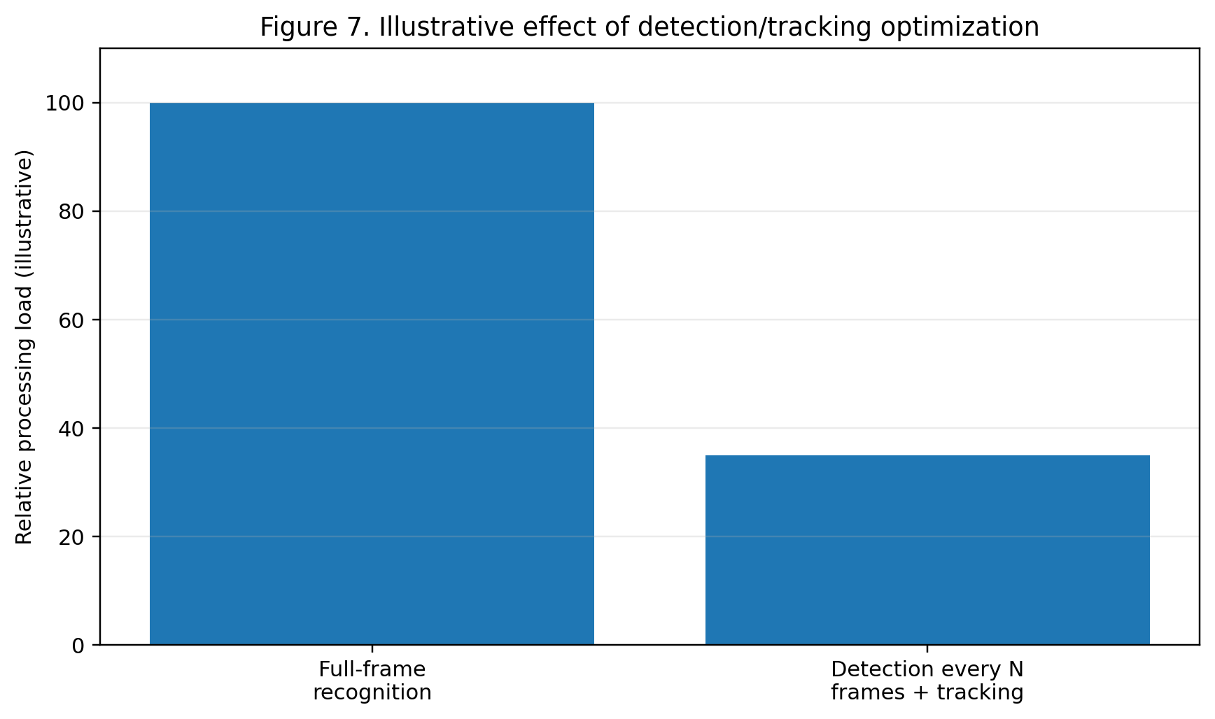
Figure 6. Illustrative relative processing-load reduction from detection/tracking optimization; values are conceptual, not measured results.
7. Achieving Accuracy and Minimizing False Recognition
- CLAHE-based normalization keeps feature quality stable under varying entrance lighting, reducing detector and recognizer errors caused by illumination.
- Face alignment removes pose variation before matching, which sharpens the separation between genuine and impostor distance scores.
- A calibrated distance/confidence threshold (tuned on a validation set of registered vs. unregistered faces) directly controls the false-acceptance rate; raising it trades recall for stricter security.
- Requiring a match to persist across two or three consecutive frames before logging attendance/access suppresses one-off false positives caused by motion blur or partial occlusion.
Conclusion
The proposed OpenCV pipeline — CLAHE-based preprocessing, fast periodic detection with inter-frame tracking, aligned feature extraction, and threshold-based database matching — meets all stated requirements: it works under varying lighting, sustains real-time throughput on inexpensive hardware through detection/tracking hybridization and multithreading, and keeps false recognitions low through alignment, threshold calibration, and multi-frame confirmation.

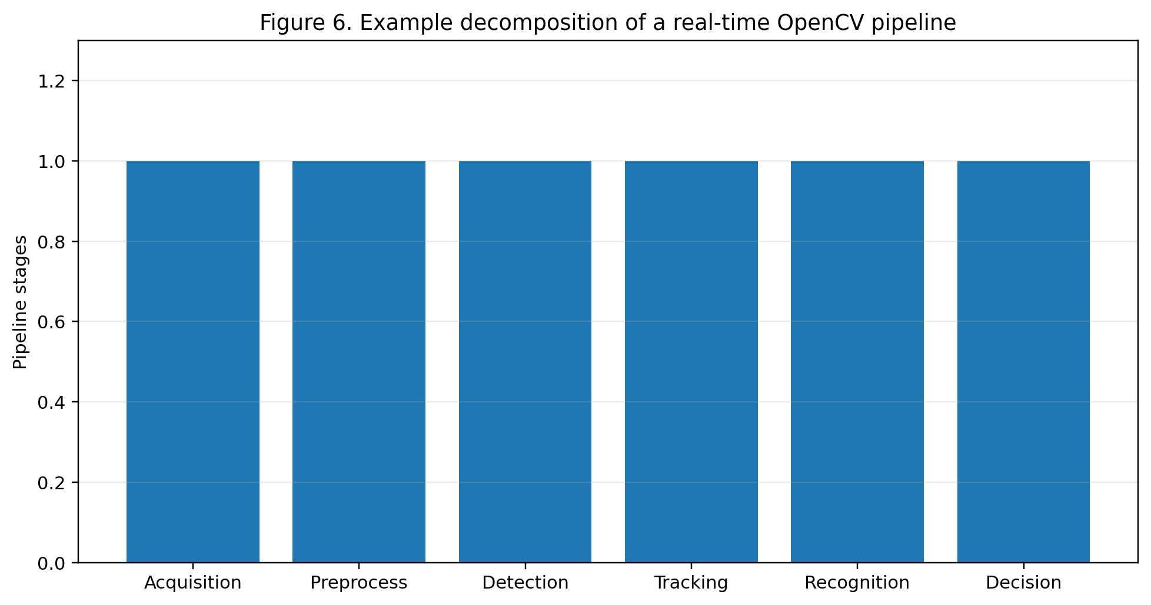
Figure 7. Example decomposition of a real-time OpenCV pipeline; conceptual illustration.
QUESTION 2 — INTELLIGENT TRAFFIC VIOLATION DETECTION SYSTEM
Question: A traffic department wants to automatically monitor vehicles using roadside cameras. The system should detect vehicles from live video, track vehicles across consecutive frames, identify vehicles crossing a predefined line, count vehicles accurately, detect abnormal or unwanted movements, and display vehicle count and alerts in real time. Design an OpenCV-based solution incorporating video acquisition, preprocessing, object detection, motion analysis, tracking, and visualization.
We will build a roadside vehicle-monitoring pipeline that detects vehicles, tracks each one across frames with a unique ID, counts line-crossings exactly once per vehicle, and flags abnormal motion, while remaining robust to shadows, noise, and dynamic backgrounds.
1. Problem Analysis
Accurate vehicle counting requires more than per-frame detection: without temporal association, the same vehicle can be counted multiple times or missed entirely across frames, and background clutter (shadows, swaying trees, lighting changes) can be mistaken for vehicles. The system therefore needs detection, a tracker that assigns persistent IDs, and a rule that fires exactly once per tracked ID when it crosses the counting line.
2. Concepts / Techniques Applied
- Video Acquisition — cv2.VideoCapture reads the roadside camera feed frame by frame.
- Preprocessing — Gaussian blur to suppress sensor noise, followed by background subtraction (cv2.createBackgroundSubtractorMOG2) to isolate moving regions.
- Object Detection — contour detection on the foreground mask for a lightweight solution, or a pretrained detector (YOLO/SSD) for higher accuracy and vehicle classification.
- Morphological Filtering — opening and closing operations remove shadow fragments and noise blobs from the foreground mask.
- Tracking — a centroid tracker or Kalman-filter-based tracker (e.g., SORT) assigns and maintains a unique ID per vehicle across frames.
- Line-Crossing Logic — a virtual counting line; a vehicle is counted once when its tracked centroid transitions from one side of the line to the other.
- Motion Analysis — trajectory direction/speed derived from consecutive centroid positions to flag abnormal movement (wrong-direction travel, sudden stops).
3. System Architecture
ROADSIDE CAMERA FEED
|
v
+---------------------------+
| Preprocessing (Blur, |
| Background Subtraction) |
+-------------+-------------+
|
v
+---------------------------+
| Morphological Cleanup |
| (Open/Close, Shadow Rem.) |
+-------------+-------------+
|
v
+---------------------------+
| Vehicle Detection |
| (Contours / YOLO-SSD) |
+-------------+-------------+
|
v
+---------------------------+
| Multi-Object Tracking |
| (Centroid / Kalman-SORT) |
+-------------+-------------+
|
+--------+--------+
| |
v v
+-----------+ +-------------------+
| Line-Cross| | Motion Analysis |
| Counter | | (Direction/Speed) |
+-----+-----+ +---------+---------+
| |
v v
Real-Time Count + Alert Display
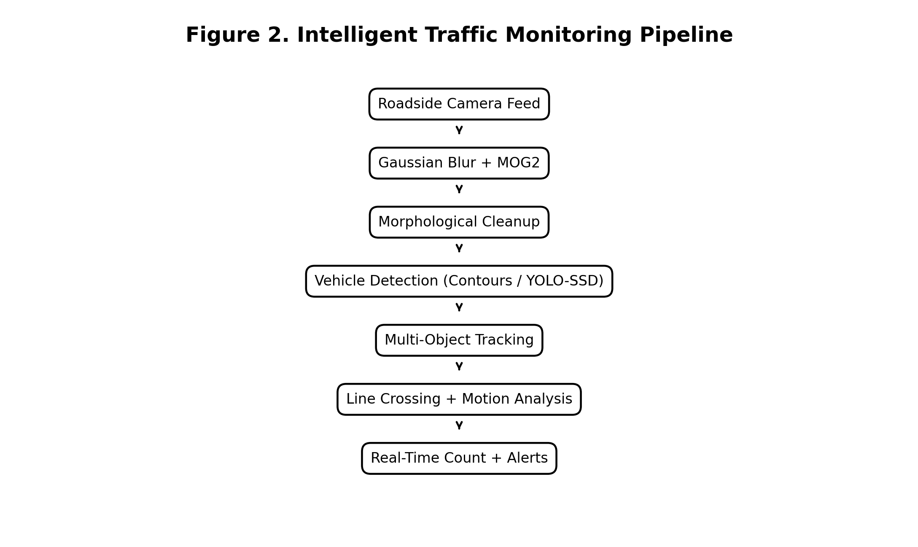
Figure 2. OpenCV-based intelligent traffic monitoring pipeline.
4. Step-by-Step Implementation
- Read frames from the camera and apply Gaussian blur to reduce sensor/compression noise before analysis.
- Feed frames into a MOG2 background subtractor; enable its built-in shadow detection so shadow pixels are labelled separately (gray, value 127) instead of as foreground.
- Threshold the foreground mask to a strict binary mask, discarding the shadow label, then apply morphological opening (remove small noise) and closing (fill vehicle silhouette gaps).
- Extract contours from the cleaned mask and filter by area/aspect ratio to keep only vehicle-sized blobs (or run a YOLO/SSD detector directly on the raw frame for stronger accuracy).
- Associate detections to existing tracks using a centroid-distance or IoU match; unmatched detections start new tracks, and a Kalman filter predicts position during brief occlusion.
- For each track, check whether its centroid has crossed the predefined counting line since the previous frame; if so and the track has not already been counted, increment the count and mark the track as counted.
- Compute per-track velocity from centroid displacement; raise an alert if direction is opposite to expected traffic flow or speed is outside a normal range.
- Overlay bounding boxes, IDs, the running count, and any alerts on the video for real-time display/logging.
5. Pseudocode
bgSubtractor = MOG2(detectShadows = TRUE)
tracks = {}
count = 0
while (TRUE):
frame = ReadFrame()
blurred = GaussianBlur(frame)
mask = bgSubtractor.apply(blurred)
mask = RemoveShadowLabel(mask)
mask = MorphOpenClose(mask)
detections = FindVehicleContours(mask)
tracks = UpdateTracks(tracks, detections)
for t in tracks:
if CrossedLine(t) and not t.counted:
count += 1; t.counted = TRUE
if AbnormalMotion(t):
RaiseAlert(t)
DisplayOverlay(frame, tracks, count)
6. Handling Shadows, Noise, Dynamic Backgrounds, and Multiple Vehicles
- Shadows — MOG2's shadow-detection flag tags shadow pixels distinctly so they are excluded from the foreground mask before contour extraction, preventing shadow blobs from being miscounted as vehicles.
- Camera Noise — Gaussian blur before background subtraction, plus morphological opening afterward, removes isolated noise pixels that would otherwise appear as spurious small blobs.
- Dynamic Backgrounds — MOG2 continuously adapts its background model with a learning rate, so swaying trees or gradual lighting changes are absorbed into the background instead of triggering false detections; a minimum blob-area filter further rejects small background flutter.
- Multiple/Occluded Vehicles — the tracker's ID-persistence and Kalman prediction keep each vehicle's identity through brief occlusion (e.g., one vehicle passing behind another), and the counted flag per track ensures a single vehicle is never counted twice even if its detection briefly drops out and reappears.
Conclusion
Combining noise-robust preprocessing, shadow-aware background subtraction, morphological cleanup, ID-persistent tracking, and a once-per-track counting rule gives an OpenCV pipeline that counts vehicles accurately, minimizes double-counting and missed counts, and reliably flags abnormal movement in real time.

QUESTION 3 — AUTOMATED DOCUMENT PROCESSING SYSTEM
Question: A company receives thousands of scanned documents that may contain blurred text, uneven illumination, noise, and different font sizes. The system should automatically improve document quality, remove noise and unwanted background, convert the document into a suitable format for OCR, segment text regions, extract readable text efficiently, and process a large number of documents in batch mode. Design an OpenCV-based image processing pipeline for this system.
We will design a batch document-processing pipeline that cleans, binarizes, corrects, and segments each scanned page so that downstream OCR receives the highest-quality input possible.
1. Problem Analysis
Raw scans vary widely in quality: uneven illumination from scanning lamps, sensor/compression noise, skewed pages, and mixed font sizes. OCR engines are highly sensitive to input quality, so each defect must be corrected by a dedicated stage before text extraction, and the whole pipeline must run unattended over large batches without manual tuning per document.
2. Concepts / Techniques Applied
- Grayscale Conversion — reduces the image to a single intensity channel, which is what thresholding and OCR require, and cuts processing cost.
- Filtering / Denoising — Gaussian or median blur (or Non-Local Means denoising) removes scan/sensor noise while preserving character edges.
- Thresholding — adaptive thresholding or Otsu's method converts the page to a clean black-and-white image, compensating for uneven illumination across the page.
- Morphological Operations — dilation joins broken character strokes, erosion removes stray noise specks, and opening/closing clean up the binarized text mask.
- Geometric Correction — Hough-transform or contour-based skew detection followed by an affine rotation straightens tilted scans; perspective correction handles photographed (non-flat) documents.
- Segmentation — contour or projection-profile analysis isolates lines, words, and text blocks, separating text from background graphics or tables.
- Batch Automation — the pipeline is wrapped in a loop/script (with multiprocessing) that applies every stage automatically to each file in a folder and writes OCR-ready output for each.
3. System Architecture
BATCH OF SCANNED DOCUMENTS
|
v
+---------------------------+
| Grayscale Conversion |
+-------------+-------------+
|
v
+---------------------------+
| Noise Filtering (Median/ |
| Gaussian / NL-Means) |
+-------------+-------------+
|
v
+---------------------------+
| Adaptive / Otsu |
| Thresholding |
+-------------+-------------+
|
v
+---------------------------+
| Morphological Cleanup |
| (Dilate/Erode/Open/Close) |
+-------------+-------------+
|
v
+---------------------------+
| Geometric Correction |
| (Deskew / Perspective) |
+-------------+-------------+
|
v
+---------------------------+
| Text Region Segmentation |
+-------------+-------------+
|
v
OCR Engine (Tesseract) -> Extracted Text
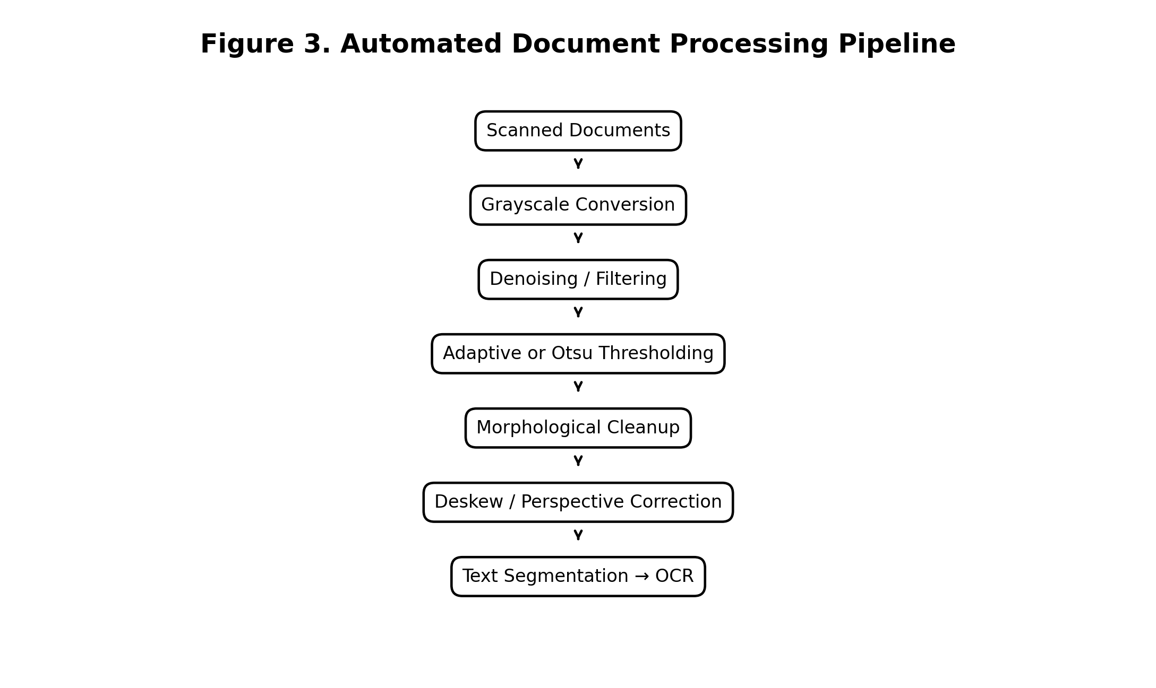
Figure 3. OpenCV-based automated document processing pipeline.
4. Step-by-Step Implementation
- Load each document image and convert it to grayscale with cv2.cvtColor.
- Apply a median or Non-Local Means filter to remove speckle/compression noise without blurring character edges.
- Apply adaptive thresholding (cv2.adaptiveThreshold) rather than a single global threshold, so pages with uneven lamp illumination still binarize correctly across the whole page; use Otsu's method as a fast alternative for evenly-lit scans.
- Apply morphological dilation to reconnect thin/broken strokes from low-resolution or blurred text, then erosion/opening to remove leftover noise specks.
- Detect page skew (e.g., via Hough line detection on text baselines or the minimum-area bounding rectangle of foreground pixels) and rotate the image to correct it; apply a perspective transform if the source was photographed rather than flat-scanned.
- Segment text regions using contour detection or horizontal/vertical projection profiles to isolate lines and paragraphs, discarding non-text regions such as logos or table borders.
- Feed each cleaned, segmented region to the OCR engine (e.g., Tesseract via pytesseract) and collect the extracted text.
- Wrap the entire sequence in a batch loop (optionally multiprocessed) that iterates over the input folder, so thousands of documents are processed unattended.
5. Pseudocode
for file in DocumentFolder:
img = ReadImage(file)
gray = Grayscale(img)
clean = DenoiseFilter(gray)
binary = AdaptiveThreshold(clean)
binary = MorphCleanup(binary)
angle = EstimateSkew(binary)
corrected = Rotate(binary, angle)
regions = SegmentTextRegions(corrected)
text = ""
for region in regions:
text += OCR(region)
SaveText(file, text)
6. How Each Stage Improves OCR Accuracy
- Grayscale conversion — removes irrelevant color information so binarization and OCR operate on a consistent single-channel signal, reducing false edges from color noise.
- Filtering — suppresses random pixel-level noise that would otherwise be mistaken for character strokes or gaps, which OCR engines misread as extra/missing letters.
- Thresholding — produces sharp, high-contrast black text on a white background, which is the input format OCR engines are tuned for; adaptive thresholding specifically prevents uneven lighting from washing out or over-darkening parts of the page.
- Morphological operations — repair broken character strokes (improving recognition of blurred or low-DPI text) and eliminate residual speckle noise that could be misread as punctuation.
- Geometric correction — straightens skewed or perspective-distorted text lines, since OCR line-segmentation assumes roughly horizontal text; uncorrected skew is one of the largest causes of OCR error.
- Segmentation — isolates genuine text regions from tables, images, or stamps, preventing OCR from wasting effort on non-text content and reducing garbled output from mixed content blocks.
Conclusion
A pipeline of grayscale conversion, denoising, adaptive thresholding, morphological cleanup, geometric correction, and text-region segmentation converts noisy, skewed, unevenly-lit scans into clean, well-formed input for OCR, and wrapping this pipeline in a batch loop lets the company process thousands of documents automatically with consistently higher text-extraction accuracy.

QUESTION 4 — REAL-TIME MULTI-PERSON TRACKING AND ATTENDANCE SYSTEM
Question: A college wants to automatically record student attendance using classroom CCTV cameras. The system should detect multiple faces simultaneously, track each person across video frames, recognize registered students, avoid repeatedly marking the same student, handle slight head movement and temporary face disappearance, and operate continuously with minimum processing delay. Design a complete OpenCV-based system using face detection, feature extraction, recognition, and tracking.
We will design a classroom attendance pipeline that detects all visible faces per frame, tracks each person with a persistent ID, recognizes them once per session, and marks attendance exactly once per student even through brief movement or occlusion.
1. Problem Analysis
Unlike single-face entrance recognition, a classroom scene requires detecting and following many faces at once. Running full recognition on every face in every frame is expensive and unnecessary; the real challenge is maintaining a stable identity per student across frames so that recognition only needs to run occasionally per track, and so that one student is never logged twice or missed because they turned their head briefly.
2. Concepts / Techniques Applied
- Multi-Face Detection — a DNN-based detector (SSD/MTCNN) locates all faces in each frame, which is more robust to varied poses and partial occlusion than Haar cascades in a crowded classroom.
- Multi-Object Tracking — each detected face is assigned a track using a centroid tracker or a correlation-based tracker (e.g., cv2.TrackerKCF/CSRT) combined with IoU matching, giving each student a stable ID across frames.
- Feature Extraction and Recognition — a face embedding (e.g., a compact CNN/LBPH) is computed once a track is confirmed stable, and matched against the enrolled student database.
- Identity Persistence — once a track is recognized, its identity label is cached and reused for that track without re-running recognition every frame, and attendance is logged only the first time a track is confirmed.
- Track Re-Acquisition — if a track is lost (student turns away or is briefly occluded), a short grace buffer keeps the track alive; if the same face reappears nearby within that window it is re-linked to the same track/ID rather than treated as a new person.
3. System Architecture
CLASSROOM CCTV FEED
|
v
+----------------------------+
| Multi-Face Detection (DNN) |
+--------------+-------------+
|
v
+----------------------------+
| Multi-Object Tracker |
| (ID assignment / IoU match)|
+--------------+-------------+
|
new/unrecognized track?
|
v
+----------------------------+ +----------------------+
| Feature Extraction & |<----->| Registered Student DB|
| Recognition (once/track) | +----------------------+
+--------------+-------------+
|
v
+----------------------------+
| Attendance Log (mark once |
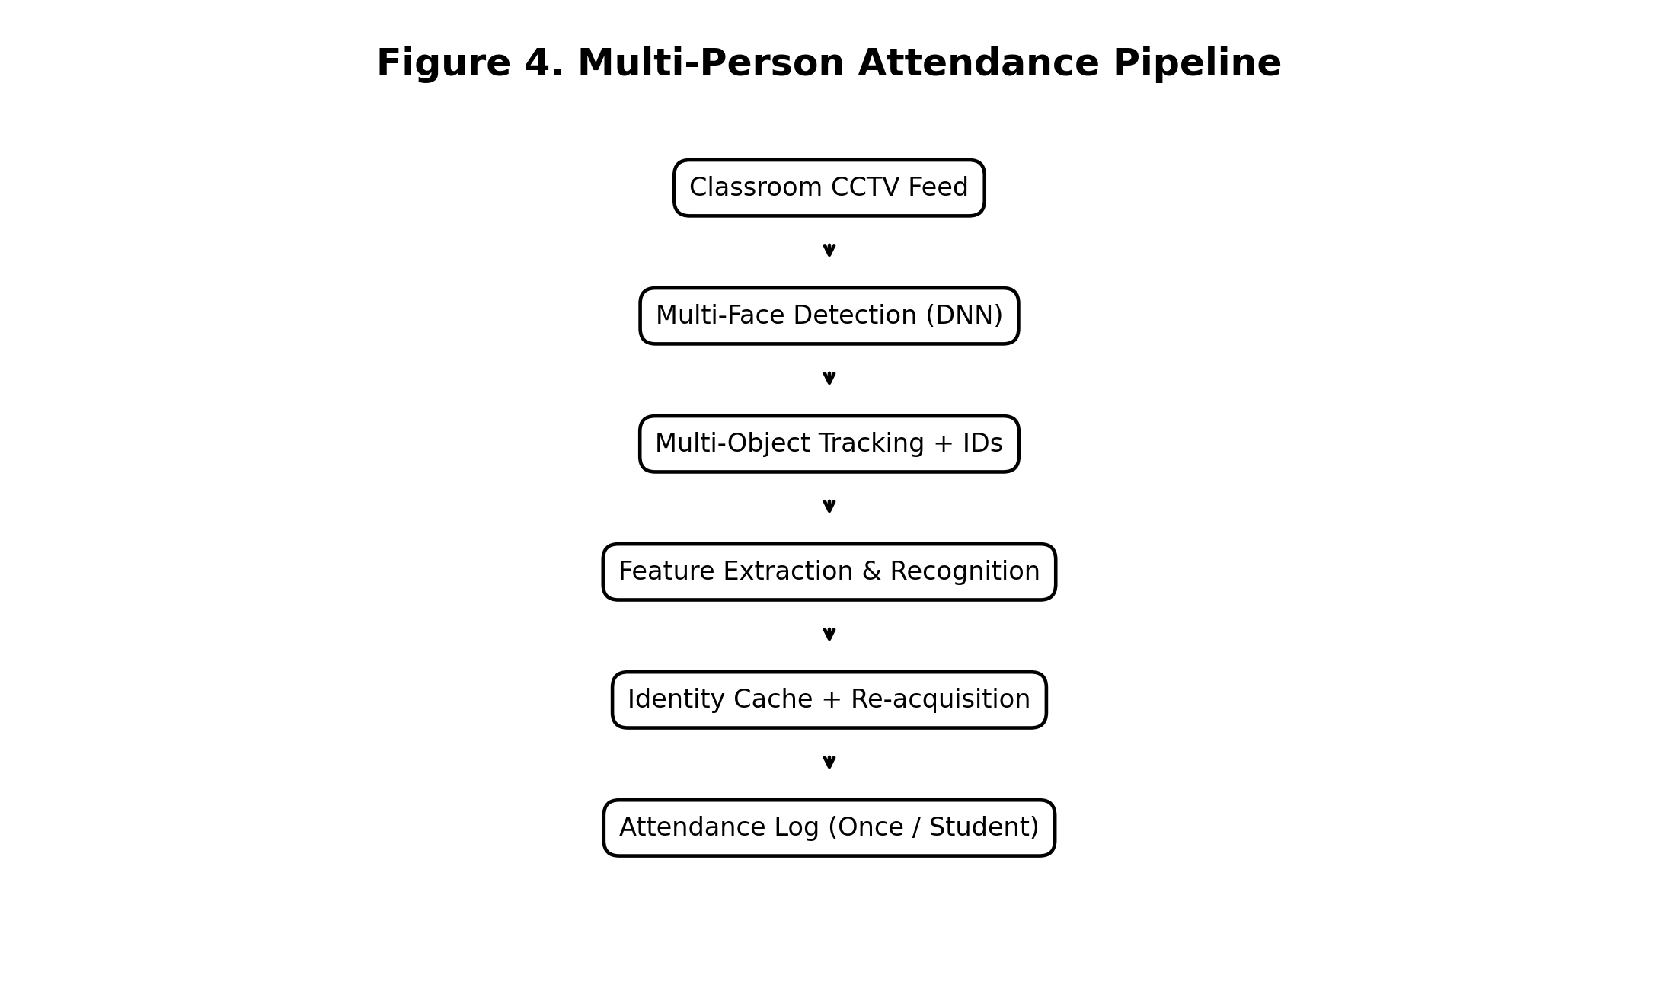
Figure 4. OpenCV-based multi-person attendance pipeline.
| per Student ID per session)|
+----------------------------+
4. Step-by-Step Implementation
- Run a DNN face detector on each frame (or every few frames) to get all face bounding boxes present in the classroom.
- Match new detections to existing tracks by IoU/centroid proximity; unmatched detections spawn new tracks with a fresh temporary ID.
- For each track that has not yet been recognized, extract facial features from a good-quality frame (frontal, in-focus) and match against the enrolled database.
- Once a track is confidently matched to a student, cache that identity on the track and mark attendance for that student if not already marked in the current session.
- On subsequent frames, simply propagate the cached identity for that track without re-running recognition, keeping per-frame cost low.
- If a track disappears (occlusion/head turn), keep it alive in a short-lived buffer with its last known position and identity; if a new detection appears within the buffer window and nearby position/appearance, re-link it to the same track instead of creating a duplicate.
- After the buffer window expires without re-acquisition, retire the track — the student's attendance record remains marked from the earlier confirmed recognition.
5. Pseudocode
tracks = {}
attendance = {}
while (TRUE):
frame = ReadFrame()
detections = DetectFaces(frame)
tracks = MatchOrCreateTracks(tracks, detections)
for t in tracks:
if t.identity is None and t.stableFrames > MIN_FRAMES:
features = ExtractFeatures(t.face)
t.identity = MatchDatabase(features)
if t.identity and t.identity not in attendance:
attendance[t.identity] = Now()
ExpireStaleTracks(tracks, GRACE_WINDOW)
DisplayOverlay(frame, tracks, attendance)
6. Maintaining Identity and Preventing Duplicate Records
- Assigning a unique track ID at first detection, and only running the (comparatively expensive) recognition step once per track, keeps per-frame processing delay low even with many students in view.
- Caching the recognized identity on the track means the system does not re-ask 'who is this' every frame, and consequently cannot log the same student twice within one continuous track.
- The grace-window re-acquisition step is what specifically handles slight head movement and brief disappearance: instead of creating a new track (and risking a duplicate attendance entry) when a face is lost for a few frames, the system checks recent track history first and re-links a reappearing face to its original ID.
- A one-entry-per-student-per-session rule on the attendance dictionary is the final safeguard — even if a track is mistakenly duplicated, the attendance log itself cannot record the same student ID twice.
Conclusion
By combining per-frame multi-face detection with persistent multi-object tracking, running recognition only once per confirmed track, and re-acquiring briefly-lost tracks within a grace window, the system reliably records each student's attendance exactly once per session while sustaining real-time performance in a classroom with multiple simultaneous faces.

QUESTION 5 — SMART HOME SURVEILLANCE AND INTRUSION DETECTION
Question: A home security system uses a fixed camera to monitor an entrance continuously. The system should detect significant motion, distinguish actual movement from camera noise and small background changes, track moving objects, identify suspicious activity, generate an alert when an unauthorized person enters a predefined region, and operate in real time with limited computational resources. Design an OpenCV-based surveillance pipeline using background subtraction, filtering, morphological operations, contour/feature detection, motion analysis, and tracking.
We will design a lightweight, fixed-camera surveillance pipeline that separates genuine intruder motion from noise and background clutter, tracks the moving object, and raises an alert only when it enters a defined restricted zone.
1. Problem Analysis
A fixed home camera sees a mostly static scene, so the core signal for intrusion detection is motion relative to a learned background. The main difficulty is separating a genuine intruder from noise sources that also look like motion — sensor noise, shadows, illumination changes, and moving background elements such as trees or blowing leaves — while still running comfortably on limited hardware (e.g., a Raspberry Pi-class device).
2. Concepts / Techniques Applied
- Background Subtraction — cv2.createBackgroundSubtractorMOG2 (or KNN) builds and continuously updates a statistical background model, isolating pixels that differ from it as foreground/motion.
- Filtering — Gaussian blur applied before subtraction suppresses per-pixel sensor noise so it does not register as foreground.
- Morphological Operations — opening removes small noise blobs, closing fills gaps in a moving object's silhouette, producing a clean single blob per real object.
- Contour Detection — cv2.findContours extracts candidate moving-object shapes from the cleaned mask; filtering by minimum area rejects trivial background flutter.
- Motion Analysis / Tracking — centroid tracking across frames confirms sustained, directional motion (a real object moving through the scene) rather than a single-frame flicker.
- Zone-Based Alerting — a predefined polygon/rectangle region of interest (ROI) around the entrance; an alert fires only when a tracked object's centroid enters that ROI.
3. System Architecture
FIXED ENTRANCE CAMERA
|
v
+----------------------------+
| Gaussian Blur (Denoise) |
+--------------+-------------+
|
v
+----------------------------+
| Background Subtraction |
| (MOG2 / KNN, shadow-aware) |
+--------------+-------------+
|
v
+----------------------------+
| Morphological Cleanup |
| (Open -> Close) |
+--------------+-------------+
|
v
+----------------------------+
| Contour Detection + Area |
| Filter |
+--------------+-------------+
|
v
+----------------------------+
| Object Tracking (Centroid) |
+--------------+-------------+
|
v
+----------------------------+
| Restricted-Zone Check |
+--------------+-------------+
|
v
Alert / Log
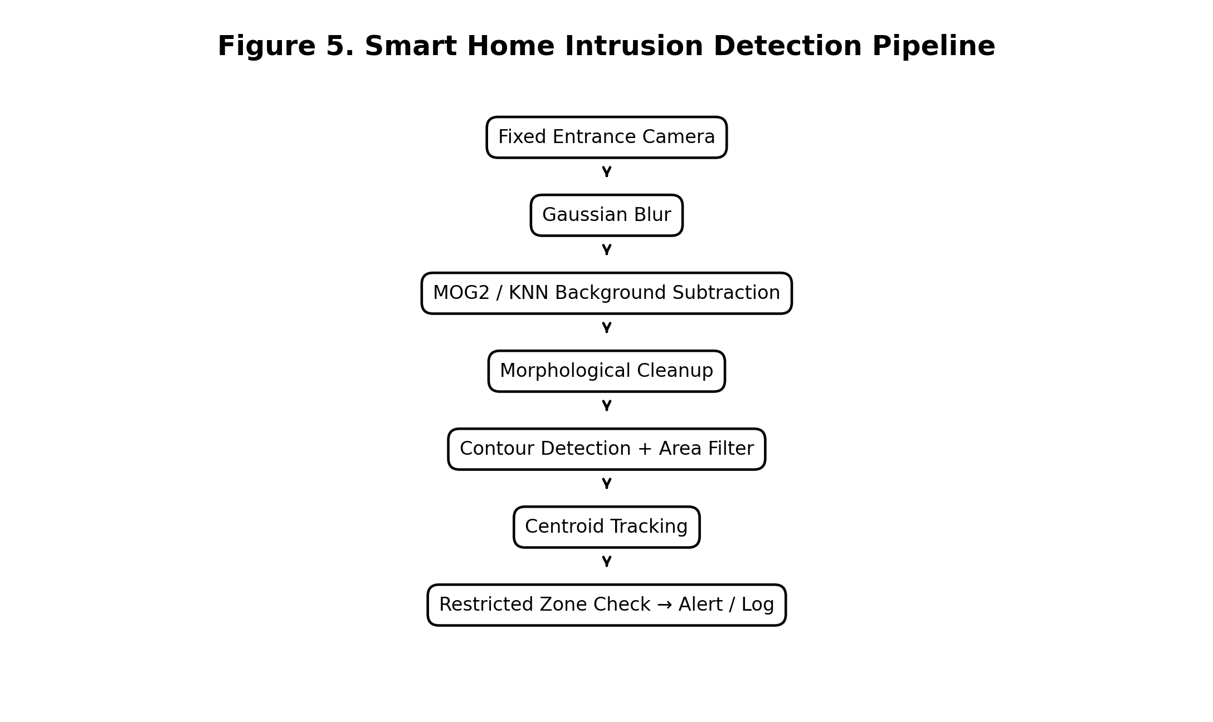
Figure 5. OpenCV-based smart home intrusion detection pipeline.
4. Step-by-Step Implementation
- Continuously read frames from the fixed camera and apply a Gaussian blur to suppress sensor noise before analysis.
- Feed each blurred frame into MOG2 (with shadow detection enabled) to build/update the background model and obtain a foreground mask, so the system adapts to slow lighting drift over the day.
- Discard the shadow label from the mask, then apply morphological opening (erode then dilate) to remove small noise blobs, followed by closing (dilate then erode) to consolidate a real moving object into one solid blob.
- Extract contours from the cleaned mask and discard any with area below a minimum threshold, rejecting leaf-sized or flicker-sized regions.
- Track the surviving contour centroids across frames; require a minimum number of consecutive frames of consistent motion before treating a blob as a genuine moving object (rejecting single-frame noise spikes).
- Check whether a confirmed track's centroid lies inside the predefined restricted-zone polygon around the entrance.
- If it does, raise an alert (on-screen highlight, log entry, notification) and continue tracking the object for as long as it remains in view.
5. Pseudocode
bgSubtractor = MOG2(detectShadows = TRUE)
tracks = {}
while (TRUE):
frame = ReadFrame()
blurred = GaussianBlur(frame)
mask = bgSubtractor.apply(blurred)
mask = RemoveShadowLabel(mask)
mask = MorphOpenClose(mask)
blobs = FindContours(mask, minArea = AREA_THRESH)
tracks = UpdateTracks(tracks, blobs)
for t in tracks:
if t.stableFrames > MIN_FRAMES and InZone(t.centroid, RESTRICTED_ZONE):
RaiseAlert(t)
DisplayOverlay(frame, tracks)
6. Reducing False Alarms from Shadows, Illumination, and Dynamic Backgrounds
- Shadows — MOG2's built-in shadow-detection flag tags cast shadows separately from true foreground, so a person's shadow does not itself register as a second moving object or extend their blob into the restricted zone prematurely.
- Illumination Changes — MOG2's continuously updated statistical background model (with a tuned learning rate) absorbs gradual lighting changes (e.g., sun moving, streetlights switching on) into the background rather than flagging the whole frame as foreground.
- Trees / Dynamic Background — the minimum-area contour filter removes small, fragmented motion typical of leaves or branches, while the requirement for sustained multi-frame motion before confirming a track filters out the short, erratic flicker typical of wind-blown foliage, which real intruders do not exhibit.
- Camera/Sensor Noise — pre-blurring the frame and applying morphological opening after subtraction both target the same failure mode: isolated single-pixel or few-pixel noise that would otherwise appear as a spurious tiny foreground blob.
Conclusion
A pipeline of noise-suppressing pre-filtering, an adaptive shadow-aware background subtractor, morphological cleanup, area- and persistence-filtered contour tracking, and a zone-based alert rule lets the system reliably detect genuine intrusions at the entrance while remaining lightweight enough for limited hardware and resistant to false alarms from shadows, lighting drift, and moving background clutter.

